

**BIONIC ENGINEERS**

Bengaluru, Karnataka, India

AN INTERNSHIP REPORT

ON

“Website for Quient Trainings Pvt Ltd”

**Bachelor of Engineering In**

**Computer Science and Engineering**

**Submitted by:**Vidhya Y- 4JN18CS122

Team Name - (hu-la-vi)



**ABOUT THE COMPANY - BIONIC ENGINEERS**

IC Solution (ICS) is a digital service provider that aims to provide software, designing and marketing solutions to individuals and businesses. At Bionic, we believe

that service and quality is the key to success

We provide all kinds of technological and designing solutions from Billing Software to Web Designs or any custom demand that you may have. Experience the service like none other!

Some of our services include:

Development - We develop responsive, functional and super-fast websites. We keep User Experience in mind while creating websites. A website should load quickly and should be accessible even on a small view-port and slow internet connection.

Mobile Application - We offer a wide range of professional Android, iOS & Hybrid app development services for our global clients, from a start up

to a large enterprise.

Design - We offer professional Graphic Bionic Engineers is a digital service provider that aims to provide software,

De design, Brochure design & Logo design.

We are experts in crafting visual content to convey the right message to the customers.

Consultancy - We are here to provide you with expert advice on your design and development requirements.

Videos - We create a polished professional video that impresses your audience.



**TABLE OF CONTENTS**

Table of contents i

Overview of the Project 3

About QUIENT TRAININGS PVT LTD 4

Why Placement Training is important 5

Tools Used 6

Implementation 7

Snapshots 8

## OVERVIEW OF THE PROJECT

**Project Name:** Website for Quient Trainings Pvt Ltd

### Team Members:

Huthasana Reddy

Latha G N

Vidhya Y

#### This project is based on Web Development And its Applications. The main objective of this project is to learn the implementation of HTML, CSS and JavaScript. The basic webpage of this project is created using HTML and styling of the webpage is done using CSS.

#### This website is about Quient Trainings which provides placement training and assistance. Placement is an important part of a student's life and training plays a vital role to fulfill the dream of getting placed in a good organisation.

**A BOUT QUIENT TRAININGS**

Quient training is an enthusiastic group intended to train students in colleges that are denied the privilege of Placement training, A group of Enthusiasts now have a vision of training students that don’t have access to placement training that can help them get placed, and thereby build their future.

##### OBJECTIVES AND TRAINING ACTIVITIES BY QG(QUIENT GROUP):

##### The prime objective of the Training Cell is :

* To look for 100% employment for all students.
* To recognize the core competencies of the students.
* To train the students to meet the expectations of the industry through our Career Development Programmes.
* To build confidence in students and develop the right attitude in them and enhance their communication skills.

##### Training Activities :

* + Create awareness about “career planning" and "career mapping" among the students.
  + Equip the student with life skills.
  + Train the students on “Personality development".
  + Organize Various Training Programmes to train the students in the areas of Quantitative Aptitude, Logical Reasoning and Verbal reasoning through the reputed external training organizations and in-house trainers.
  + Train the students through Mock Interviews to perform well in the professional interviews as per the expectations of the corporate world.
  + Train the students on group discussion techniques
  + Conduct online tests and written aptitude tests.



**WHY IS PLACEMENT TRAINING**

**IMPORTANT**

#### Placement training plays a major role in shaping up the career goals of students. It is the dream of every engineering student to get placed in a top organization visiting their campus for recruitment. Keeping this key aspect into consideration, it is realized that training is important for engineering students to enhance their employability skills and achieve good placement in various Industries.

#### At present, the competition for employment is increasing every day and placement has become a challenging task. Training students and equipping them with life skills has become an important responsibility of the institution. Along with technical expertise, the development of a holistic personality is also necessary.

# TOOLS USED

### Software Requirements

* Visual Studio Code 2019.
* Google Chrome or Microsoft Edge of latest version.
* Front End: HTML, CSS, JS
* Linux 7.1 or Windows XP/7/8/10 OS or Mac OS
* Back End: phpMyadmin
* Data Base: mysql

### Hardware Requirements

* Pentium 200-MHz computer with a minimum of 64 MB of RAM (128 MB of RAM recommended).
* Monitor with a refresh rate of at least 40Hz for a smooth GUI experience (optional).

**IMPLEMENTATION**

**Github Account: https://github.com/vidyadevadiga**

**Remote Repository:**

[**https://github.com/vidyadevadiga/Winter.git**](https://github.com/vidyadevadiga/Winter.git)

**IMPLEMENTATION**

**Snapshots :**

**Fig 1 Home Page**

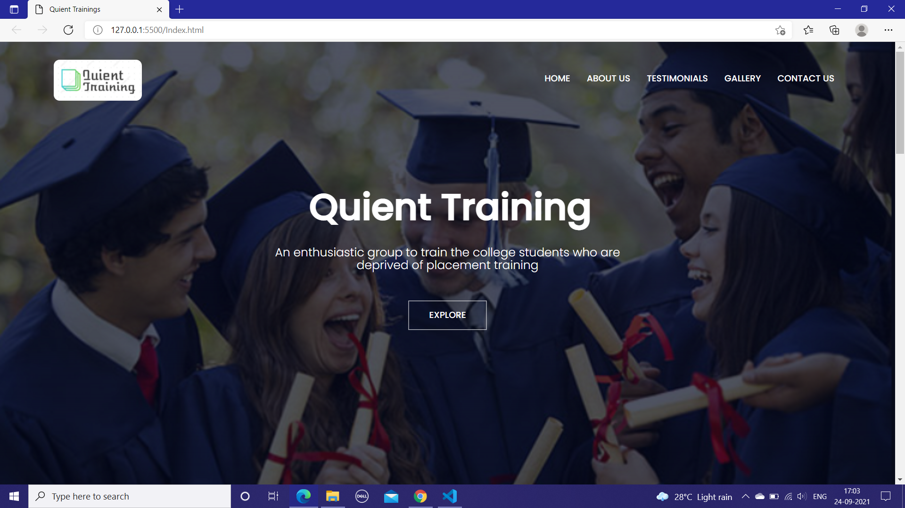

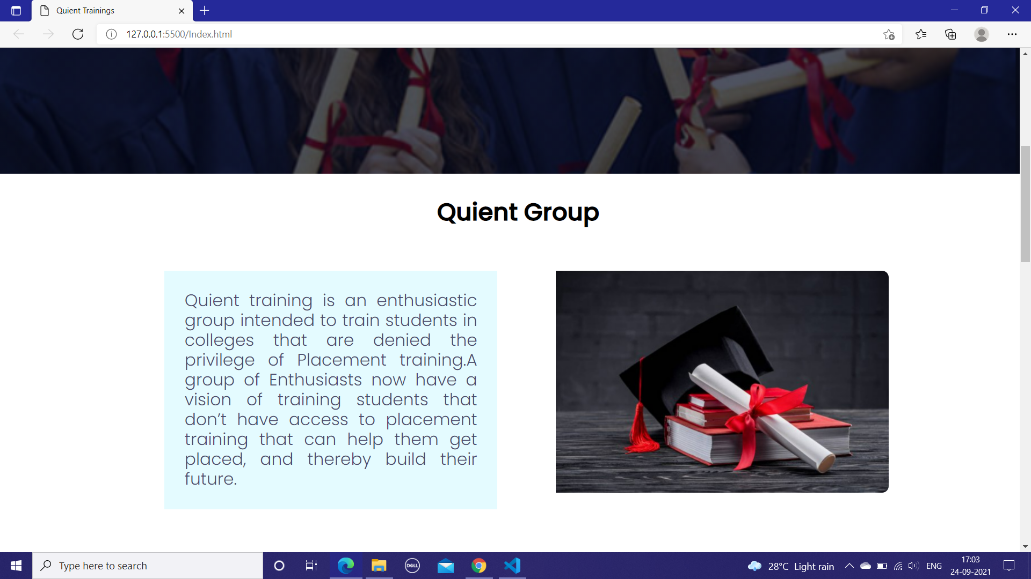

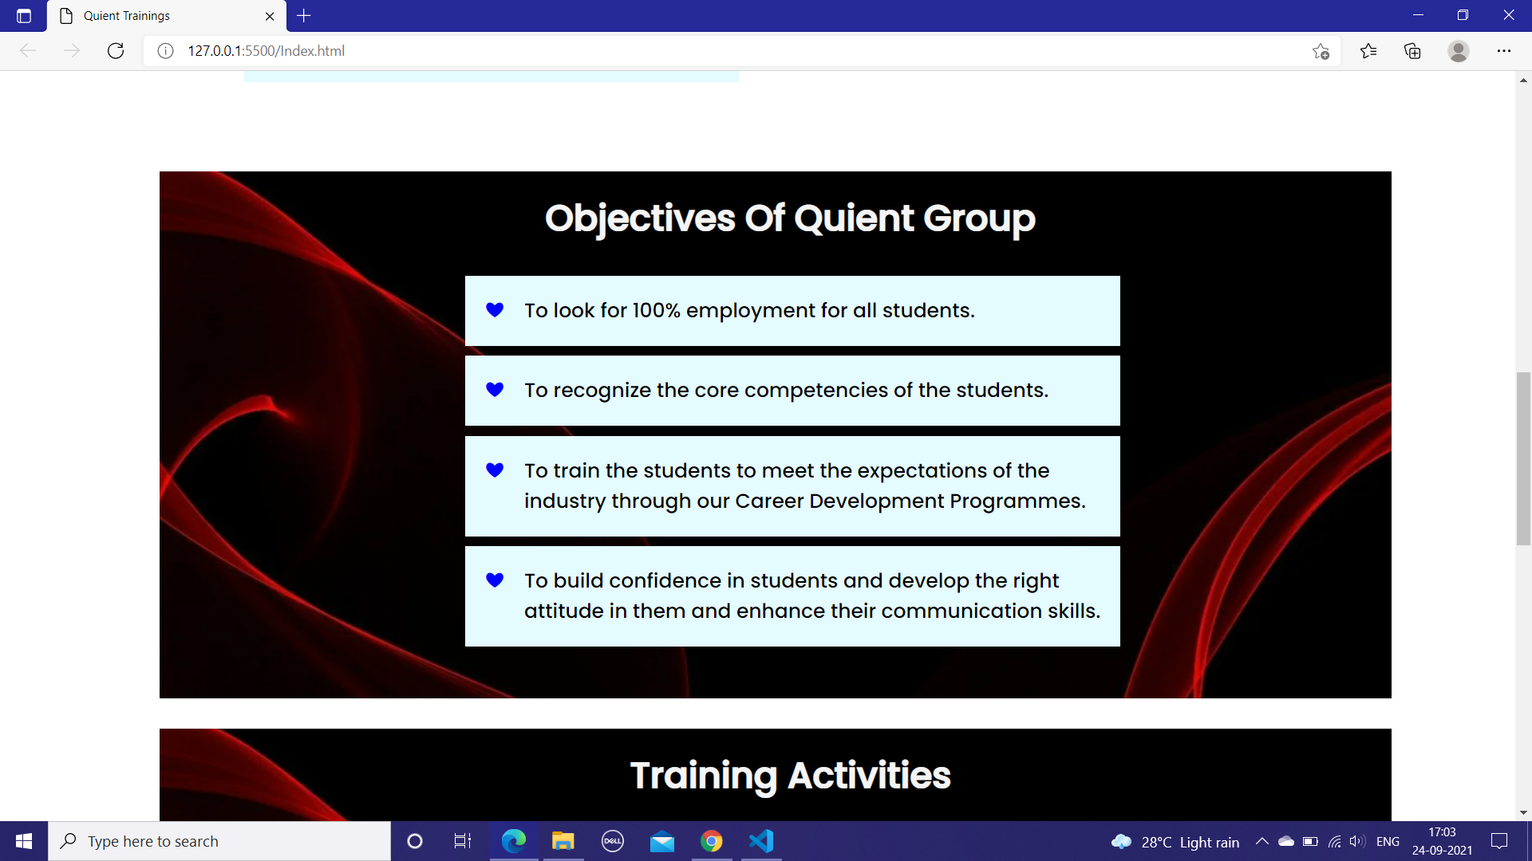

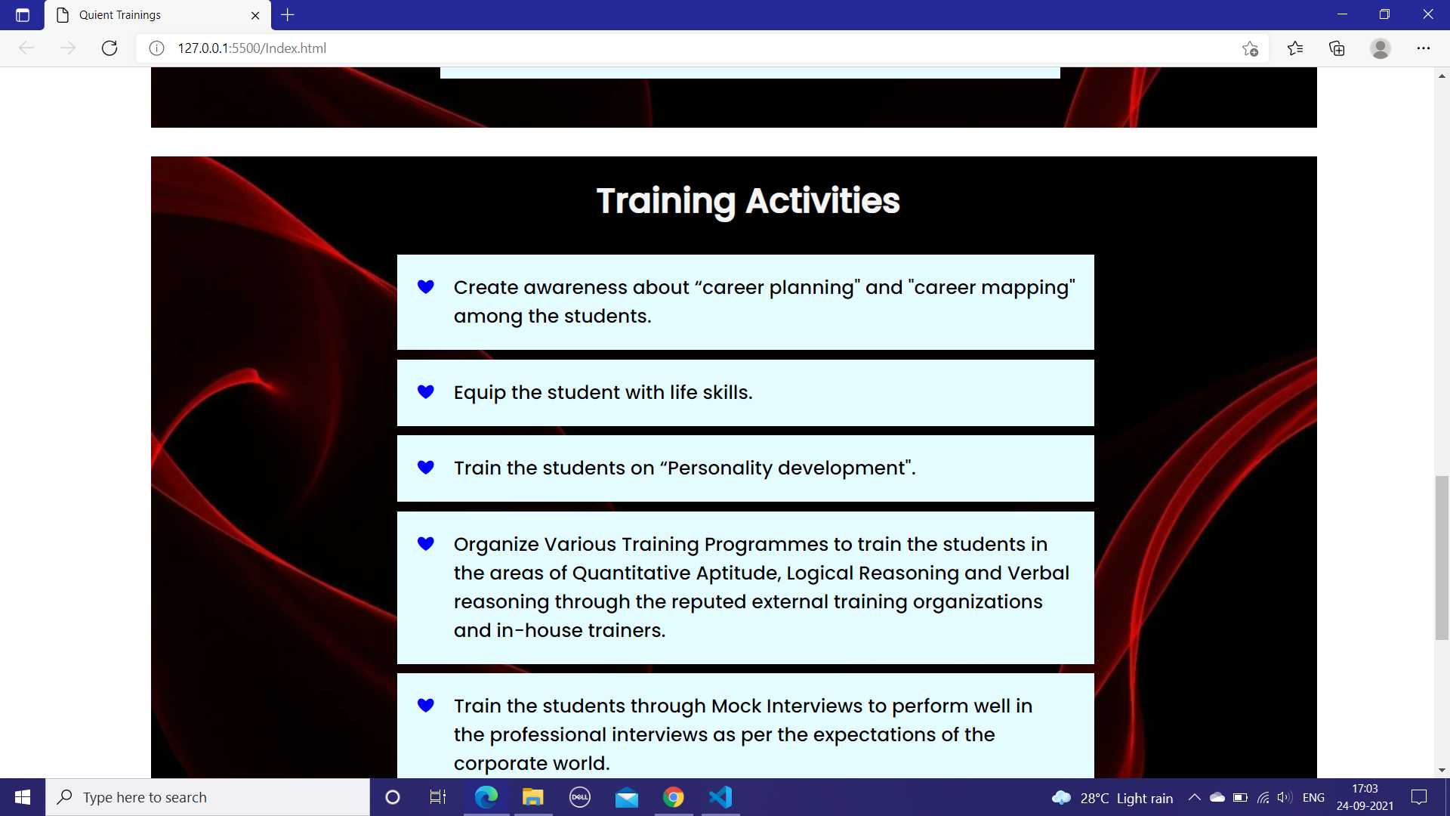

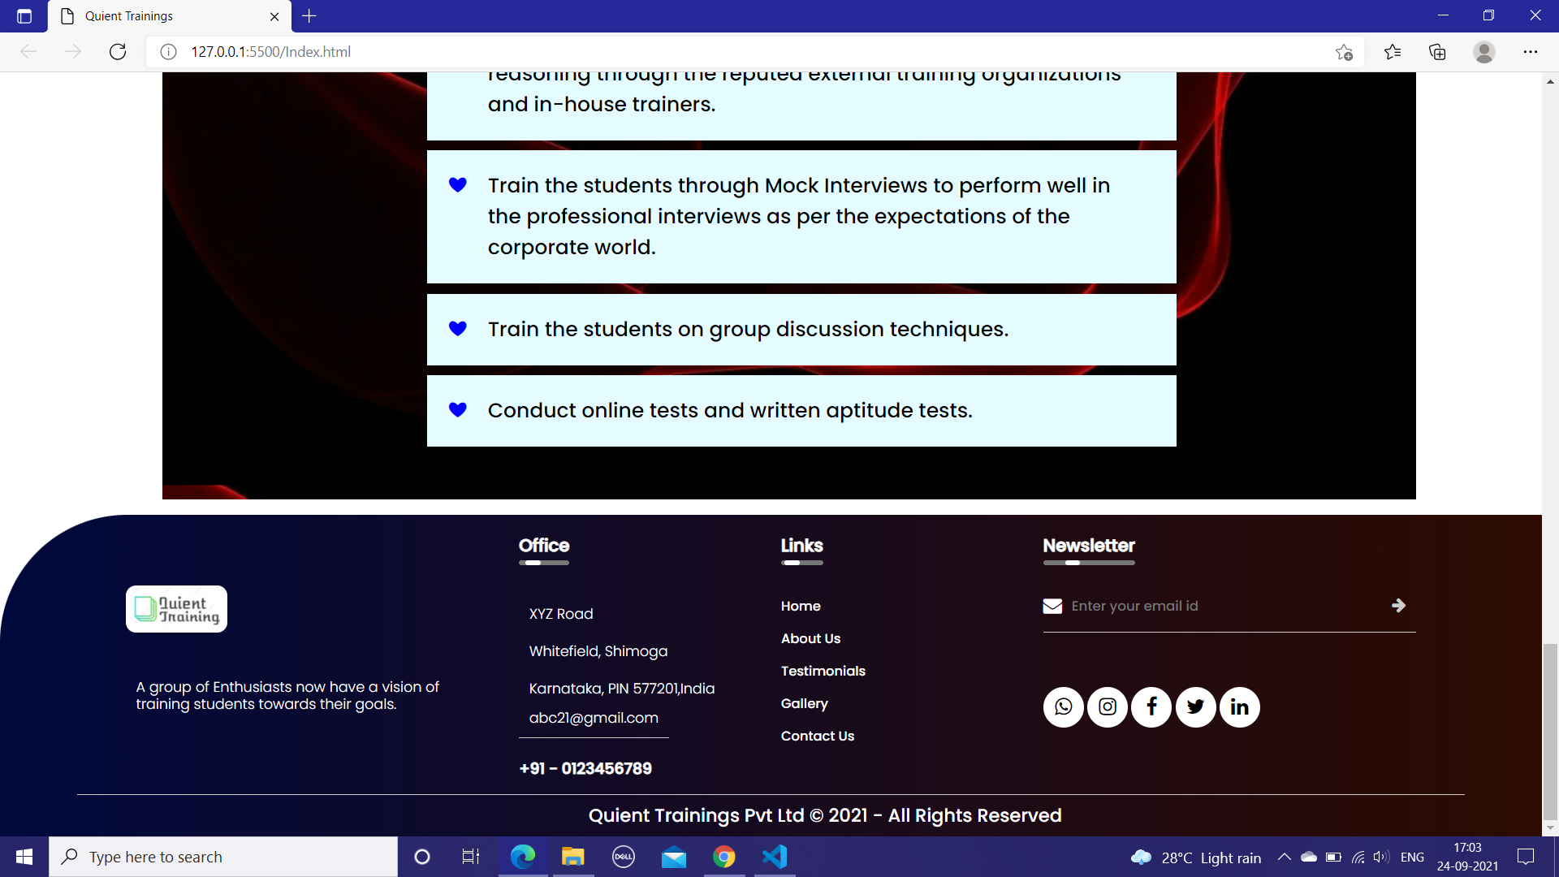

**Fig 2 Collections Page**

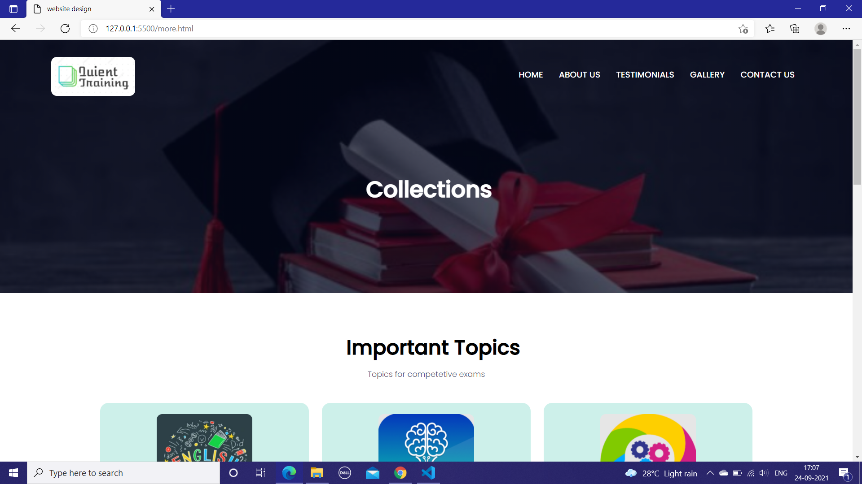

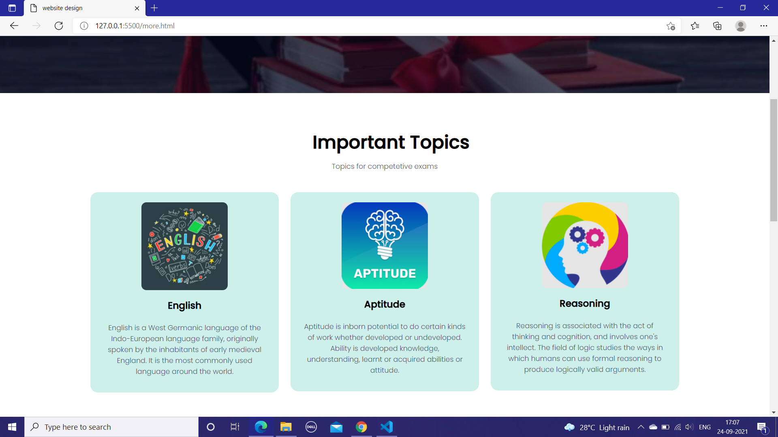

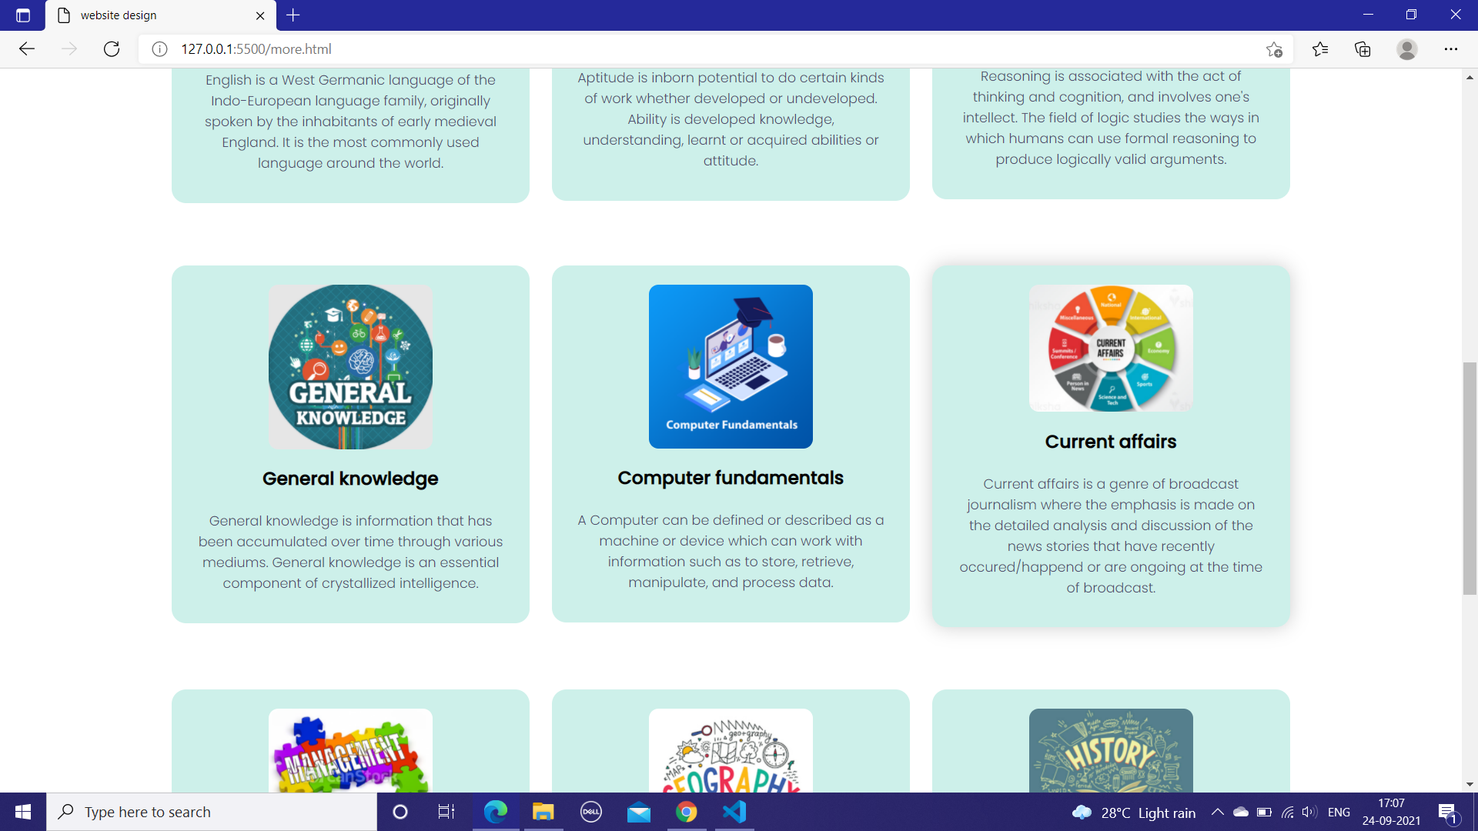

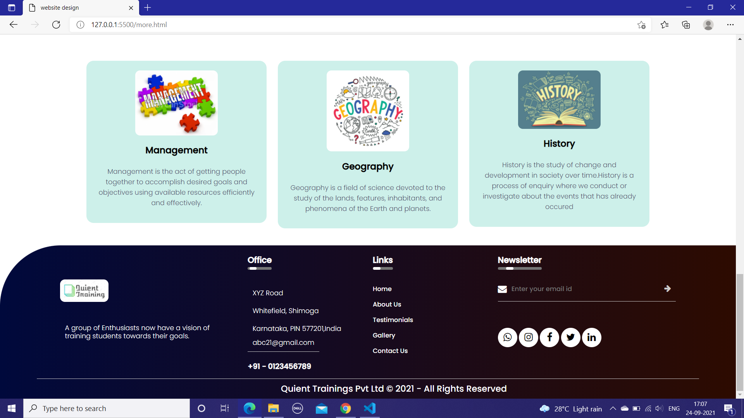

**Fig 3 About Page**

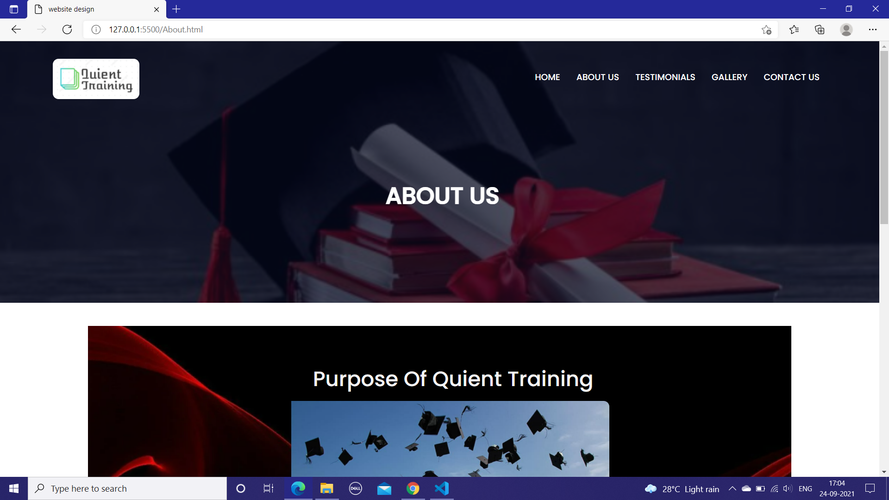

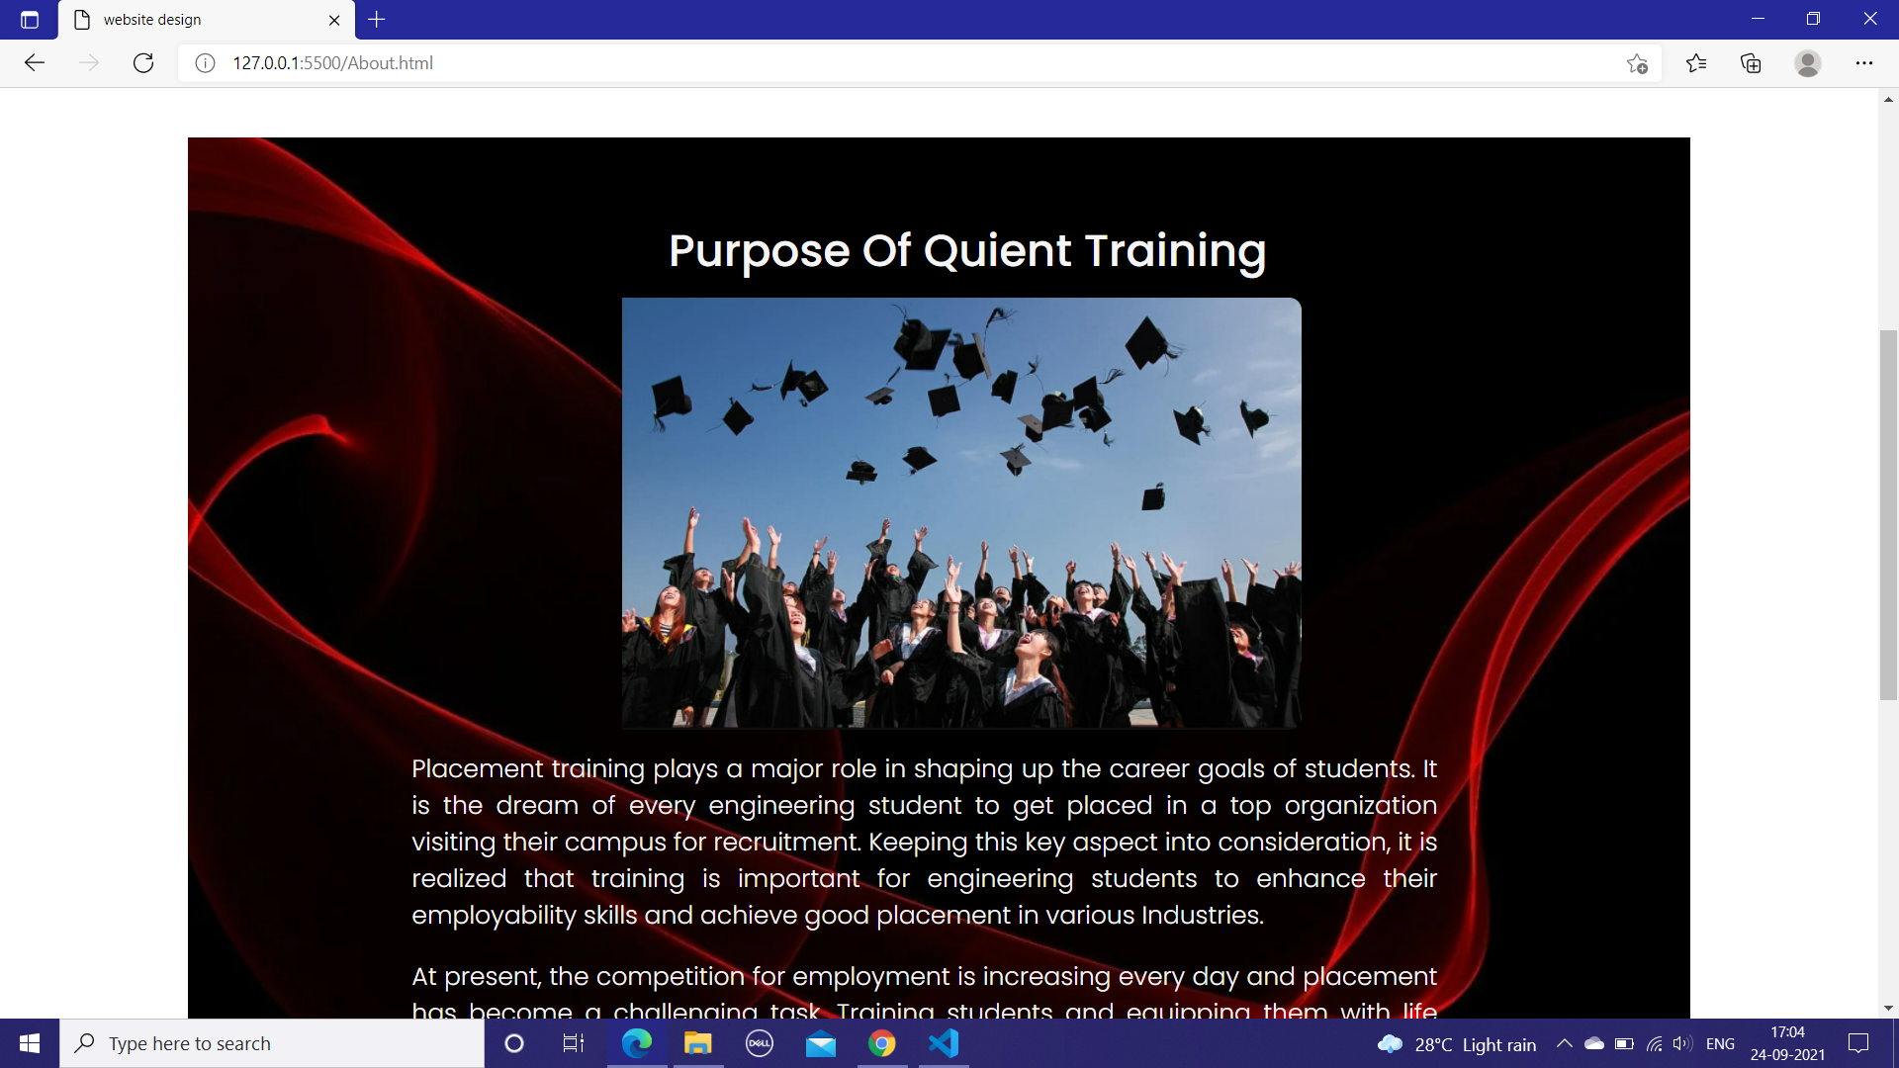

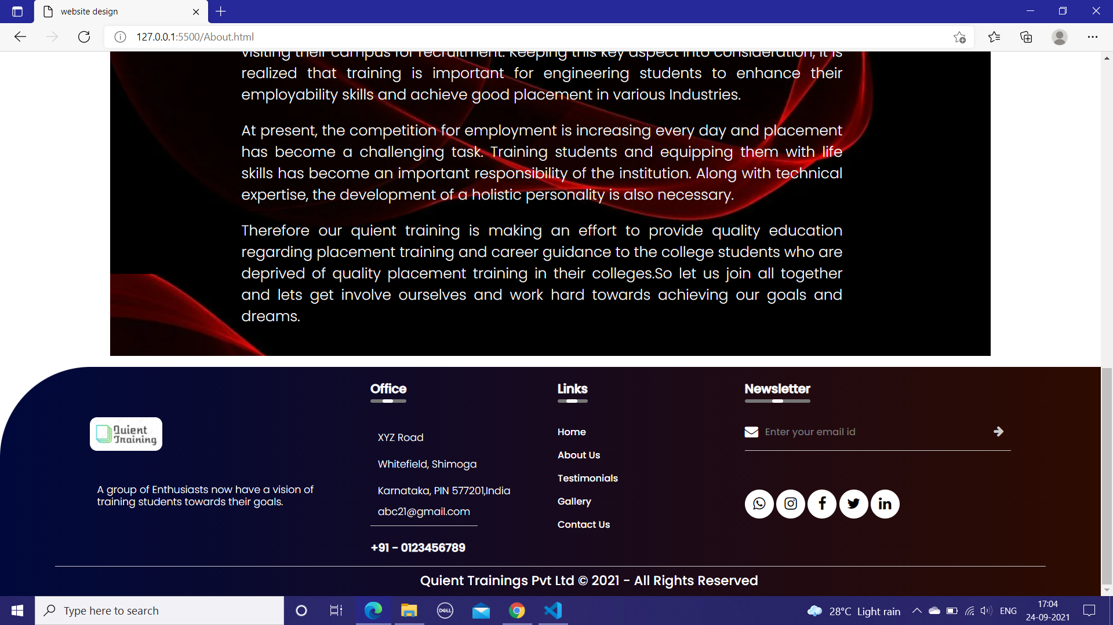



**Fig 4 Testimonial page**



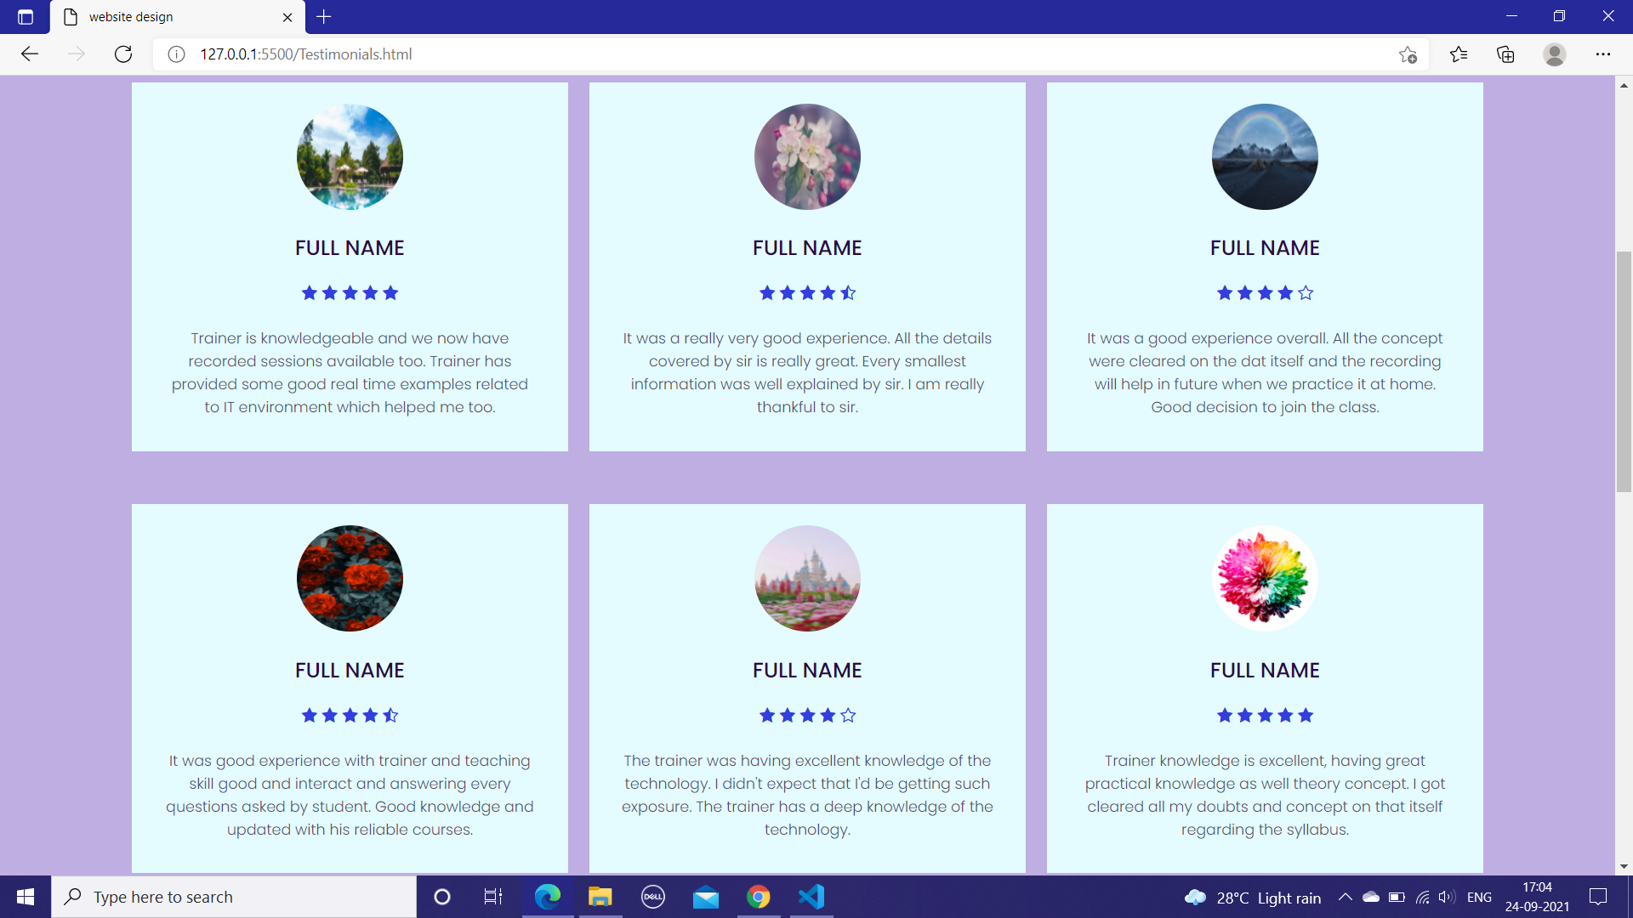



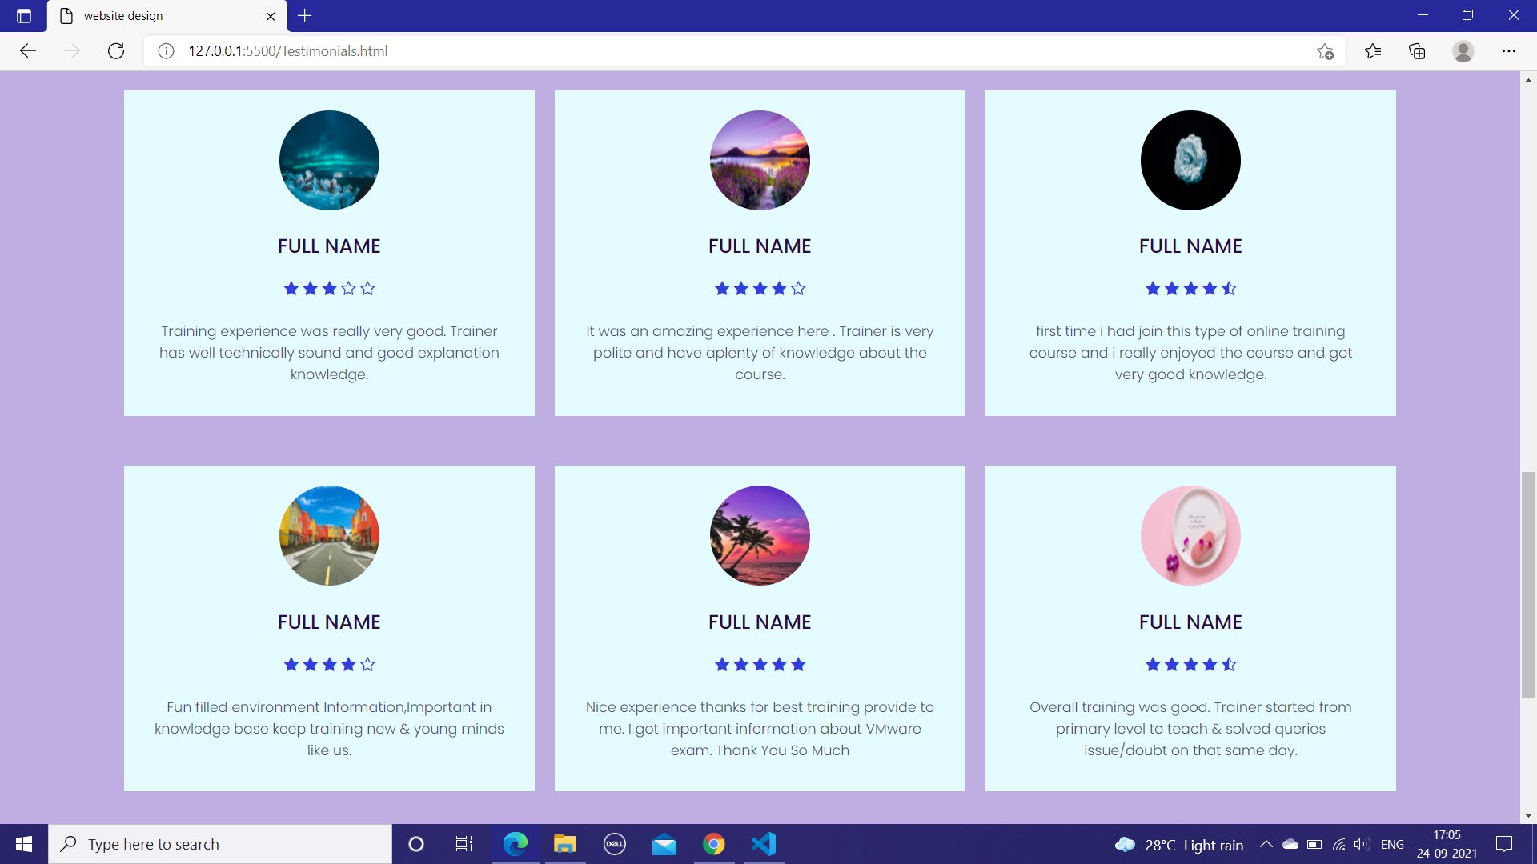



**Fig 5 Gallery Page**

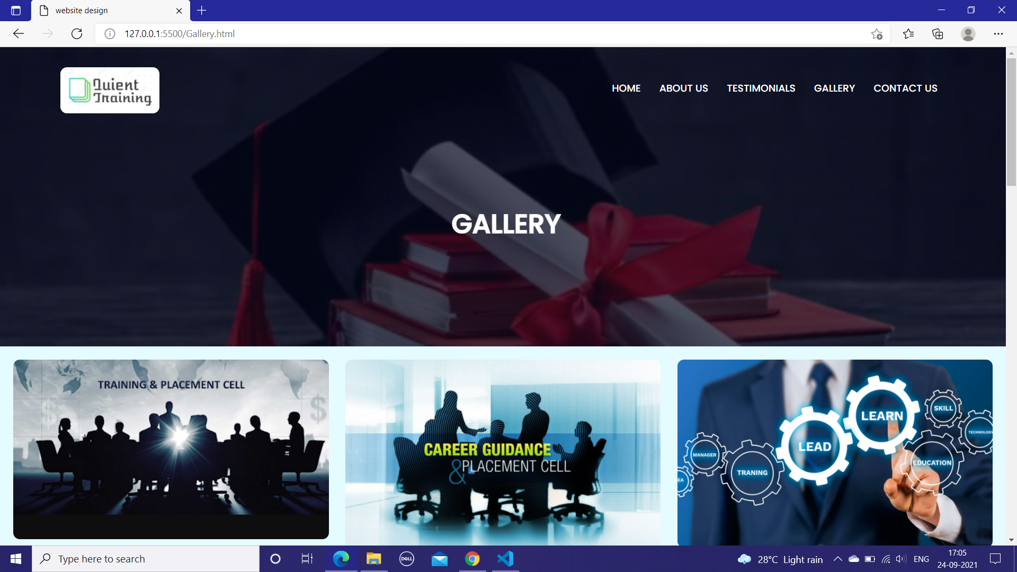

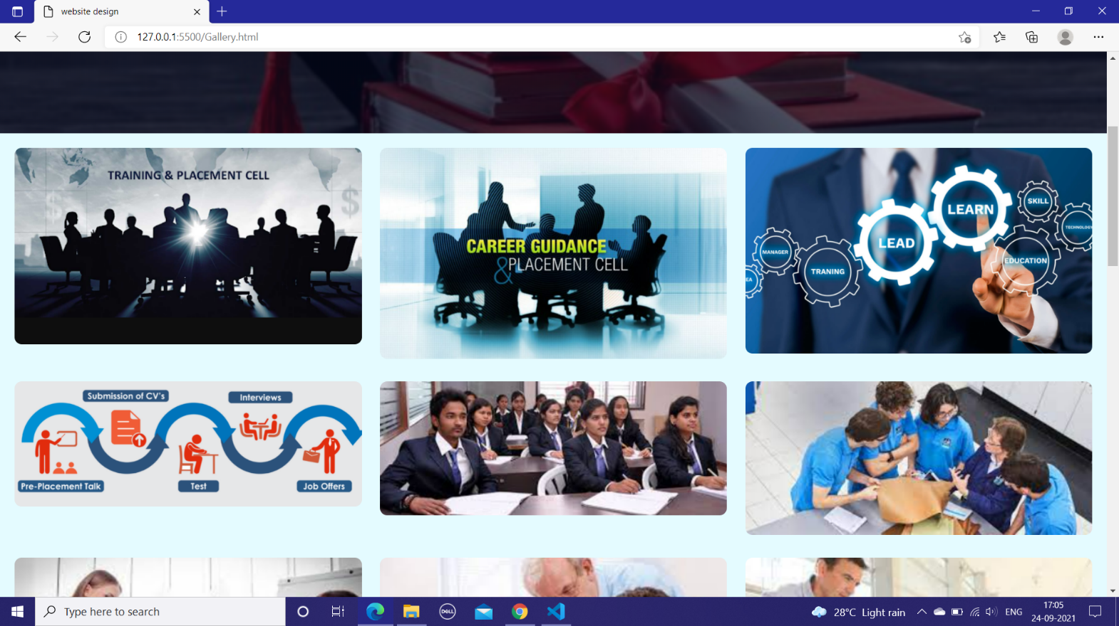



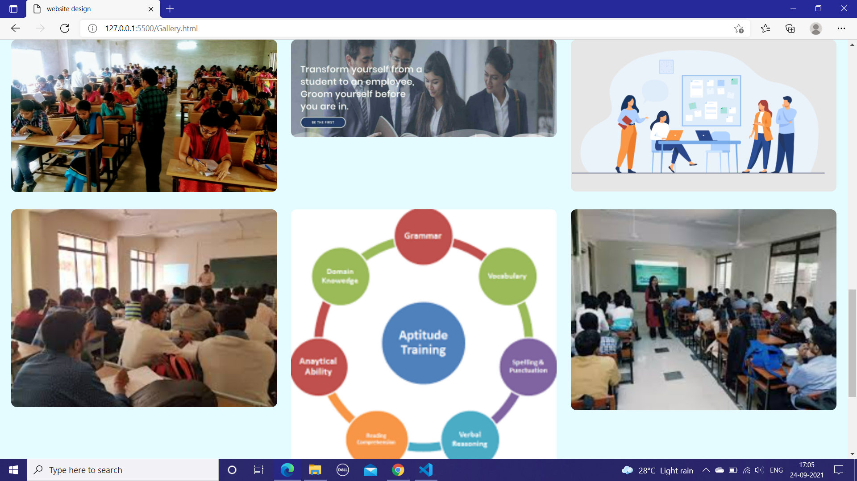

**Fig 6 Contact Page**

